📑 Research Index (Table of Contents)
- Introduction & Real-World Motivation
- Case Study: OneCoin Scam
- Problem Statement (Research Gap)
- Core Objective (Research Aim)
- Limitations of Current KYB Systems
- Existing Solutions (Industry Overview)
- Proposed Methodology (End-to-End Pipeline)
  - Data Collection
  - Graph Modeling
  - Feature Engineering
  - Anomaly Detection
- Datasets for Implementation
- Key Challenges & Research Gaps
- Proposed Advanced Solutions
- Dynamic Graph Analysis
- Event-driven Updates
- Evolution Pattern Detection
- Probabilistic KYB
- Prototype vs Production Scope
- Explainable AI (XAI) in KYB
- System Architecture (Web App Design)
- Workflow of the Application
- Project Limitations (Final Answer for Viva)
- Conclusion

📘 1. Introduction & Real-World Motivation
Financial fraud, especially through shell companies and offshore structures, is one of the biggest challenges in modern compliance systems. Traditional verification methods fail to detect complex ownership networks used for money laundering.

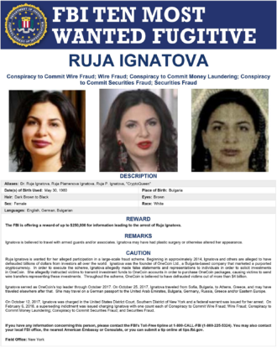

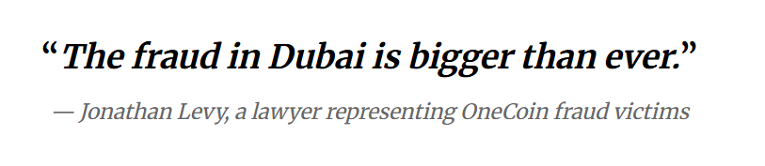


📌 2. Case Study: OneCoin Scam
A strong real-world example is the OneCoin crypto scam, exposed by International Consortium of Investigative Journalists.
- Founder: Ruja Ignatova (“Cryptoqueen”)
- Nature: Ponzi Scheme
- Jurisdictions involved: Bulgaria, Dubai, Belize
Key Insights:
- Shell companies created in Dubai
- Money laundering via offshore entities
- Luxury assets (e.g., penthouse near Palm Jumeirah) purchased through layered ownership
👉 Core Insight:
Fraud was successful not due to lack of intelligence, but due to data fragmentation + jurisdiction barriers.

⚠️ 3. Problem Statement (Research Gap)
There is no unified system capable of tracking and analyzing multi-layered ownership structures across jurisdictions.
Key Issues:
- Data silos across countries
- Lack of interoperability between:
  - Banks
  - Land registries
  - Crypto exchanges
Result:
Funds move through multiple shell layers before detection → making recovery almost impossible.

🎯 4. Core Objective (Research Aim)
Develop a Graph-based KYB system to detect:
- Layering patterns
- Circular ownership
- Hidden Ultimate Beneficial Owners (UBO)
👉 Main goal:
“Detect the network behind shell companies, not just individual entities.”

🏦 5. Limitations of Current KYB Systems
Traditional KYB systems:
- Static (annual filings)
- Rule-based
- Document-focused
Problem:
Fraudsters create dynamic networks of shell companies which:
- Change frequently
- Hide ownership through layers

🌐 6. Existing Solutions (Industry Overview)
1. Graph Analytics
- Detect hidden relationships
- Flag shared attributes (address, phone, directors)
2. Global Transparency (OECD)
- Push for ownership data sharing
3. Blockchain Forensics
- Tools like:
  - Chainalysis
  - Elliptic
👉 These link crypto transactions to real-world identities

⚙️ 7. Proposed Methodology (The 'How')
Step 1: Data Collection
- Public datasets (ICIJ, OpenOwnership, etc.)
Step 2: Graph Modeling
- Nodes = Companies, Directors
- Edges = Ownership, Control
Step 3: Feature Engineering
Detect:
- Circular ownership (A → B → C → A)
- Multi-layer ownership chains
Step 4: Detection Algorithms
- Isolation Forest
- Local Outlier Factor (LOF)

📊 8. Datasets for Implementation
Real-world datasets:
- ICIJ Offshore Leaks
- OpenOwnership (BODS)
- OpenCorporates
Synthetic datasets:
- IBM AML (SAML-D)
- BankSim
👉 Reason:
Real fraud labels are rare → synthetic data helps training

⚠️ 9. Key Challenges & Research Gaps
- Label Scarcity
  - No confirmed fraud labels
- Static Nature
  - Ownership changes frequently
- Computational Scale
  - Global graph = extremely large

🚀 10. Proposed Advanced Solutions
1. Dynamic Graph Analysis (Temporal Graphs)
- Add timestamps to edges
- Detect rapid ownership changes
2. Event-driven Updates
- Incremental graph updates instead of full retraining
3. Evolution Pattern Detection
Detect patterns like:
- “Pop-up companies”
- “Vanishing directors”
4. Probabilistic KYB
- Output risk score instead of binary result

⚖️ 11. Prototype vs Production Scope
Production (Industry)
- Real-time systems
- Large engineering teams
MSc Prototype (Your Goal)
✔ Prove that:
Graph analytics detects fraud better than traditional systems

🧠 12. Explainable AI (XAI) in KYB
Problem:
“Model says fraud—but why?”
Your Solution:
- Structural Evidence
  - Subgraph visualization (Neo4j)
- Feature Importance
  - Centrality, PageRank
- Path Analysis
  - Shortest path to risky entity
👉 This makes system usable for banks

🖥️ 13. System Architecture (Web App)
Backend:
- Python (FastAPI / Flask)
- NetworkX / PyTorch Geometric
Database:
- Neo4j (Graph DB)
Frontend:
- Streamlit
- Cytoscape.js / React Force Graph

🔄 14. Application Workflow
- User inputs company
- Backend fetches data
- Graph algorithm runs
- Risk score generated
- Graph visualization displayed

⚠️ 15. Project Limitations (VERY IMPORTANT – Viva Answer)
👉 Tumhara final answer ye hona chahiye:
- Limited to static or semi-dynamic graphs
- Focus on specific region (e.g., UK) instead of global data
- Dependence on public datasets (incomplete data)
- Use of synthetic labels for training
- Not fully real-time (batch or near real-time)
- Computational constraints for large-scale graphs
👉 One-line strong answer:
“This project is a prototype focused on proving the effectiveness of graph-based fraud detection under limited and partially available data conditions.”

🏁 16. Conclusion
This research shifts KYB from:
- Static verification → Dynamic network intelligence
👉 Final Insight:
Fraud is not in individuals, but in connections between entities.

